1. Display your name as plane text WEB Browser.

Code:

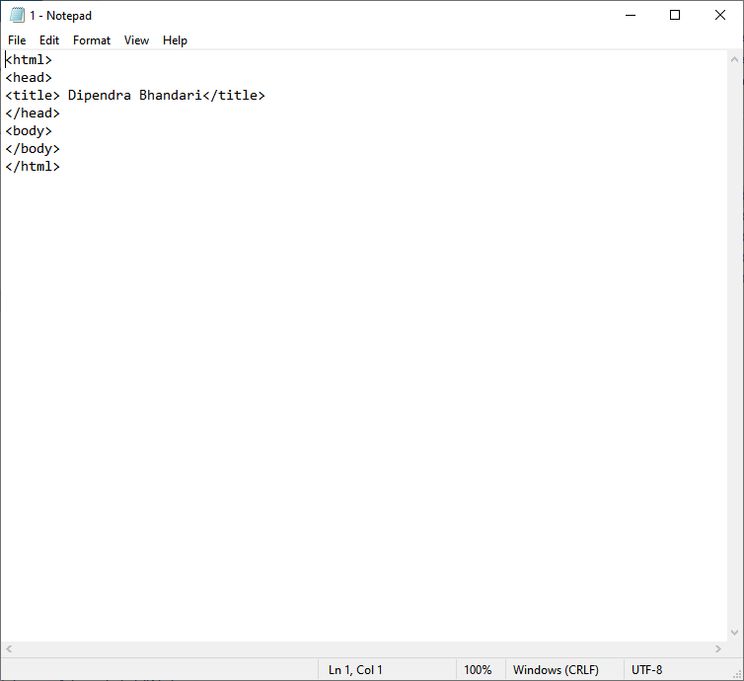

Output:

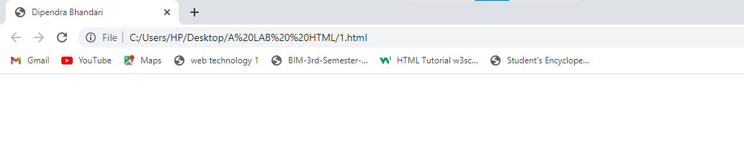

1. Display your name in WEB Browser declared inside the body.

Code:

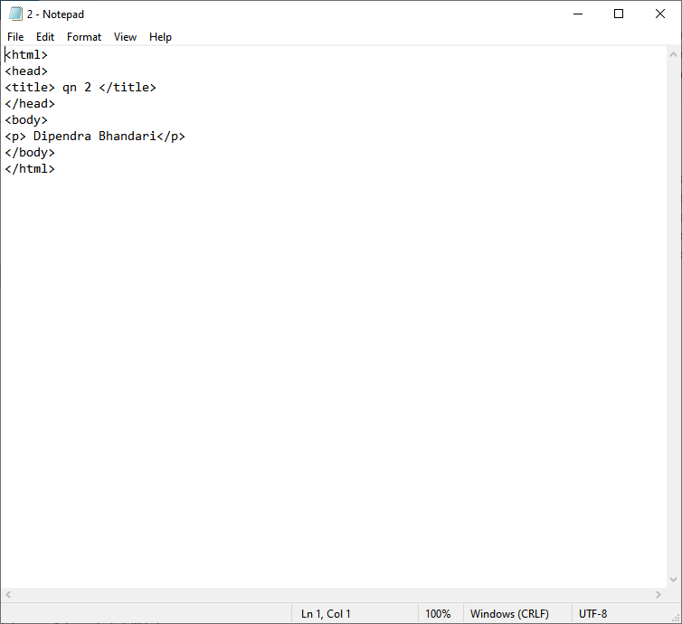

Output:

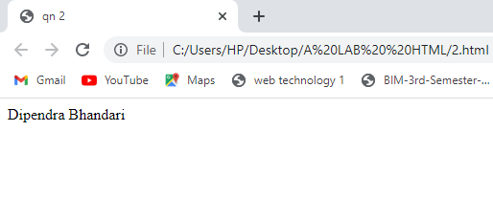

1. Write a complete source code to demonstrate the use of html, head, title, body tag.

Code:

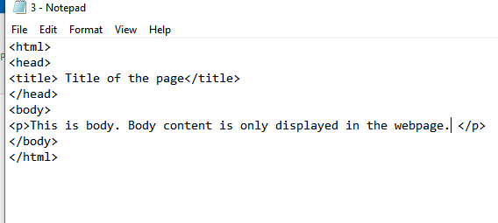

Output:

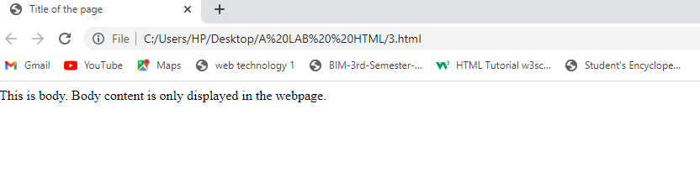

1. Write a source code to demonstrate whitespace collapsing .

Code:

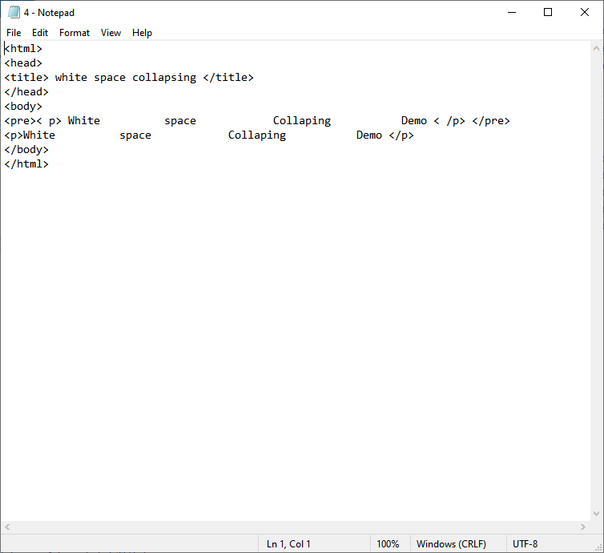

Output:

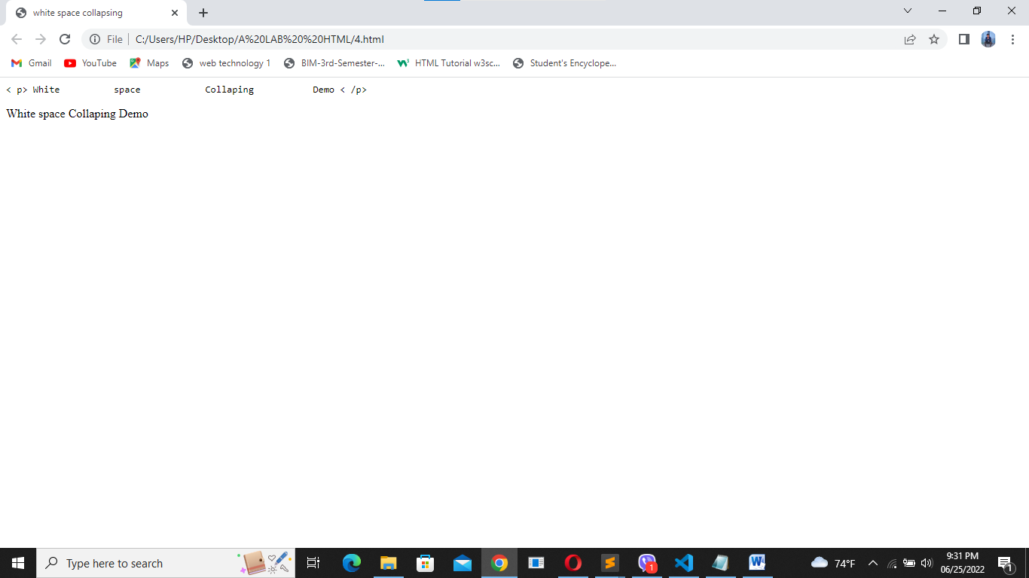

1. Create two paragraphs. Paragraph 1 containing the heading as Management Colleges in Nepal and Paragraph 2 containing the heading as Engineering Colleges in Nepal. Heading of Paragraph 2 must be smaller than the heading of Paragraph 2. Also show the use of b, i, sup, sub, small, strong, abbr, acronym, blockquote with cite attribute, cite, q tag inside the two paragraphs.

Code:

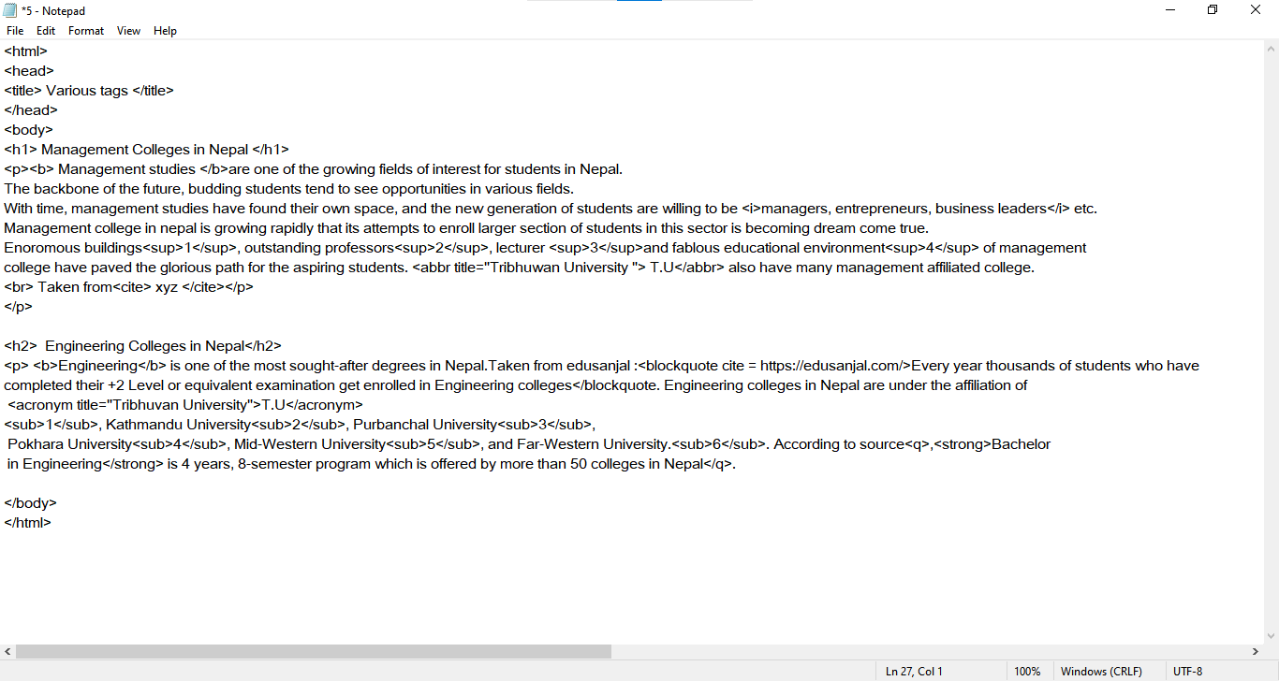

Output:

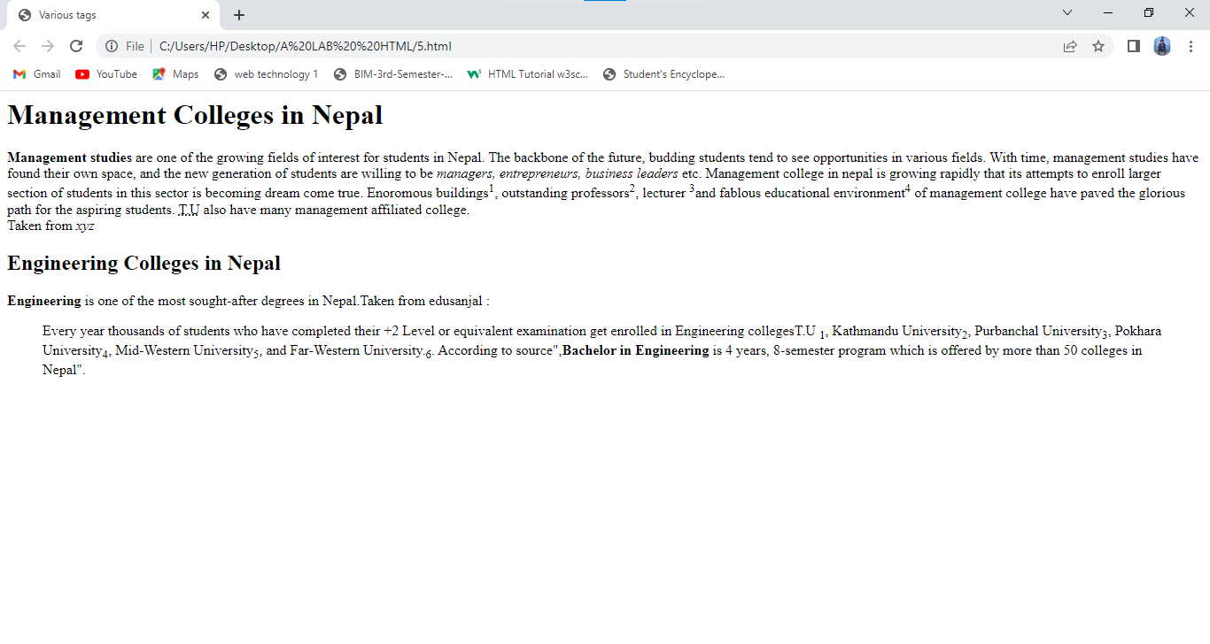

1. Write the HTML code to display the following output:

Hi,

My

Name

Is

John

Code:

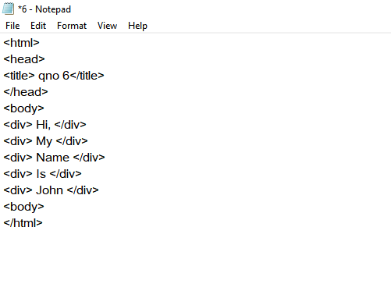

Output:

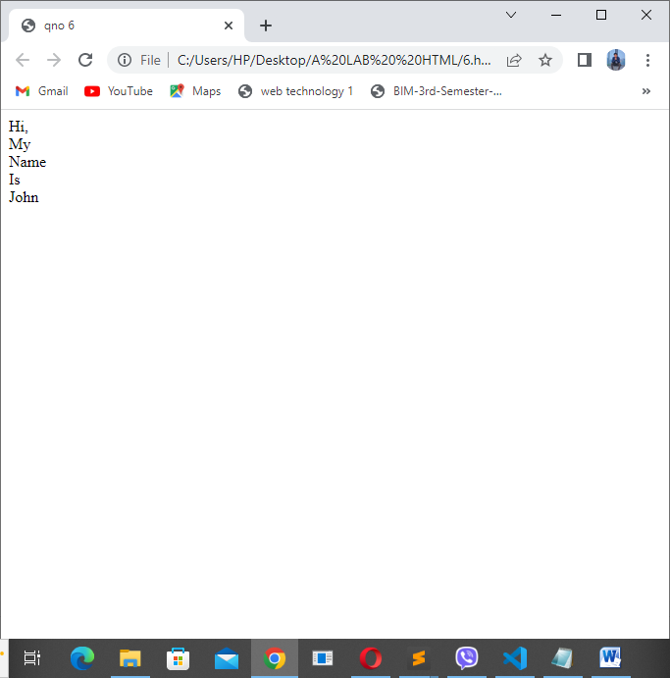

1. Write the HTML code to demonstrate
   1. code
   2. kbd
   3. var
   4. samp

Code:

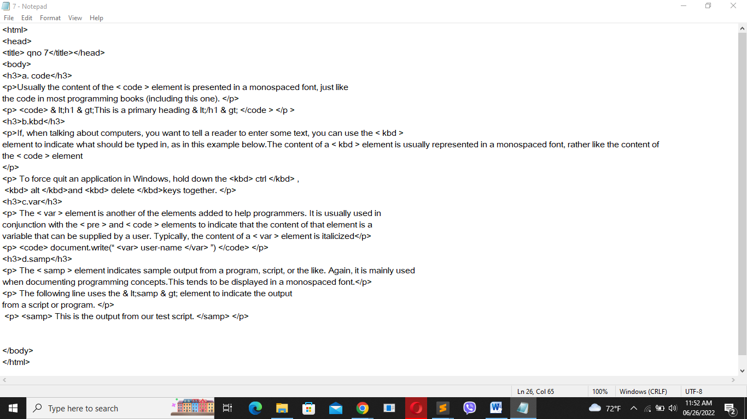

:

Output: 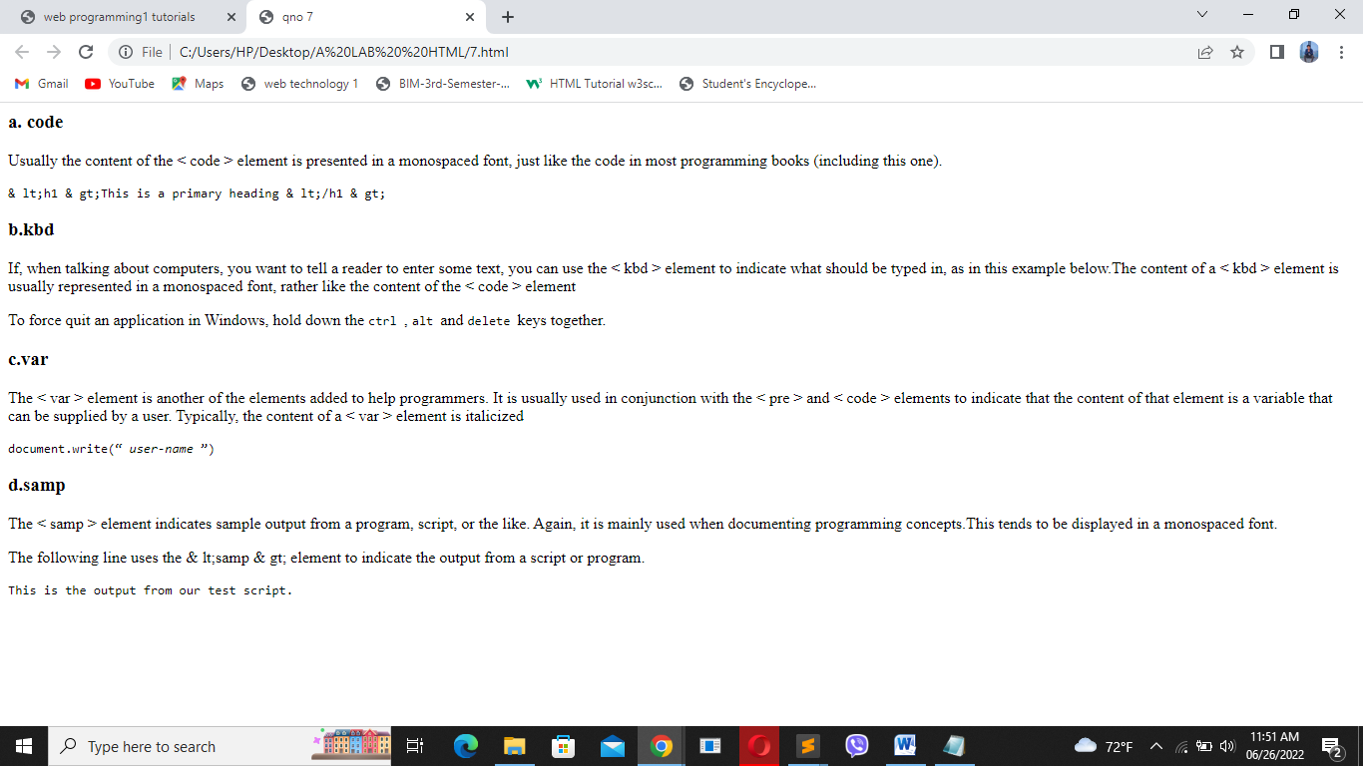

1. Write a HTML code to demonstrate the concept of :

a. Unordered list

b. ordered list

c. Nested unordered list

d. Nested ordered list

e. Definition list

Code:

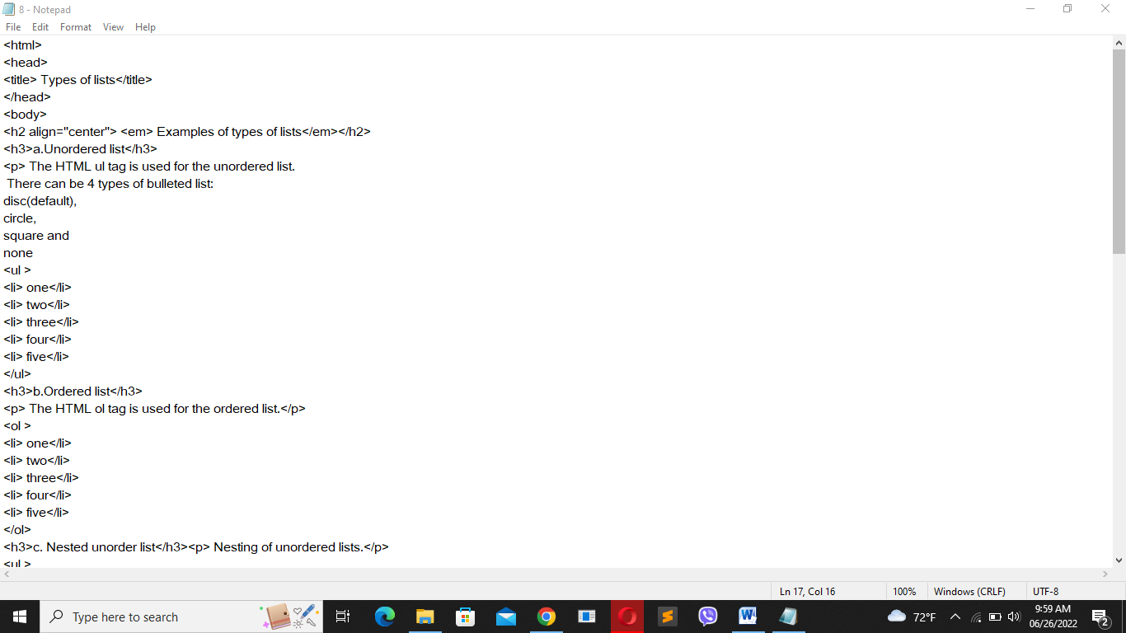

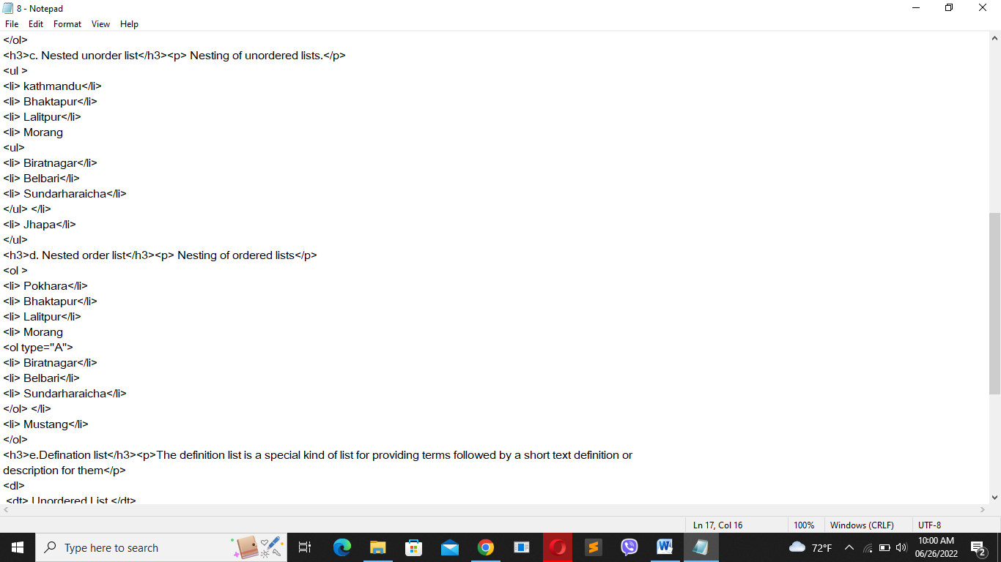

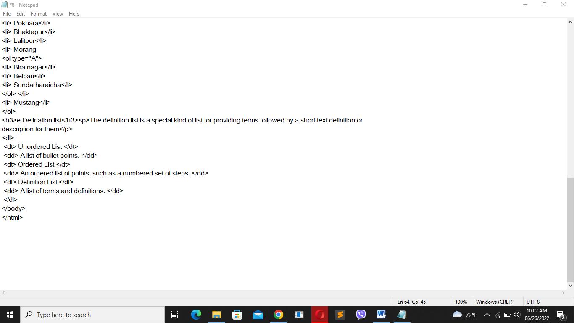

Output:

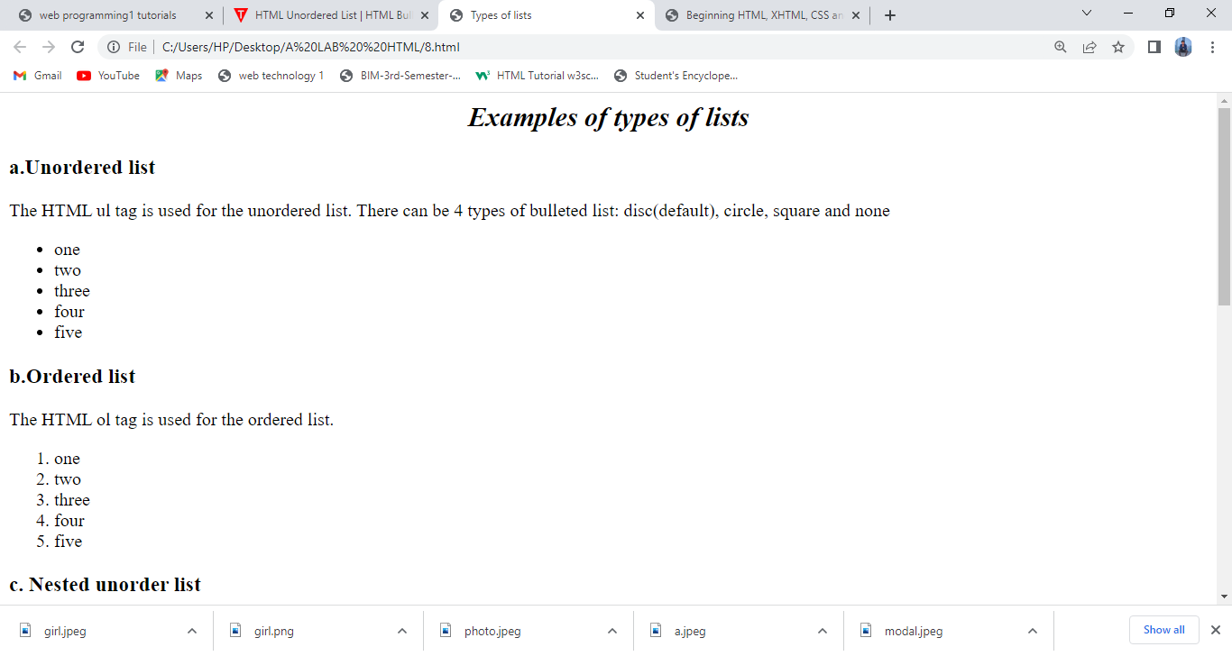

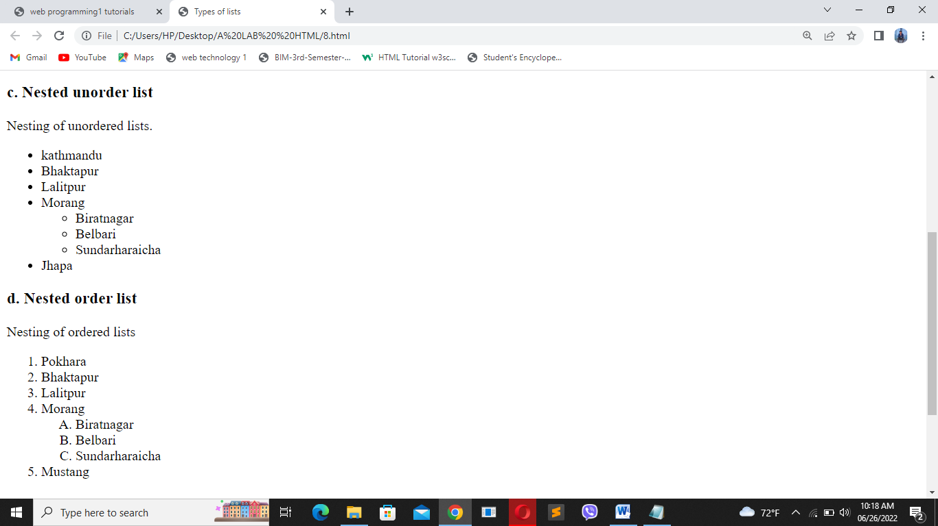

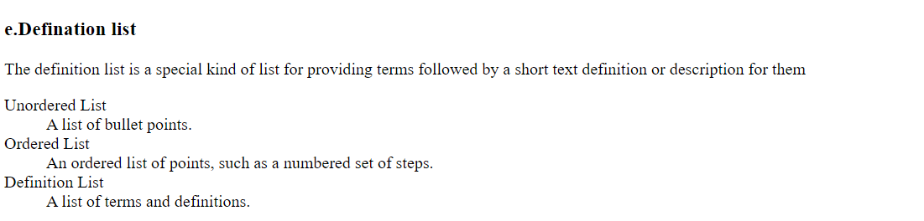

1. Write the HTML code to demonstrate image as list.

Code:

Output:

1. Code

Output:

1. Code

Output:

1. Code

Output:

1. Code

Output:

1. Add image using img tag

Code: 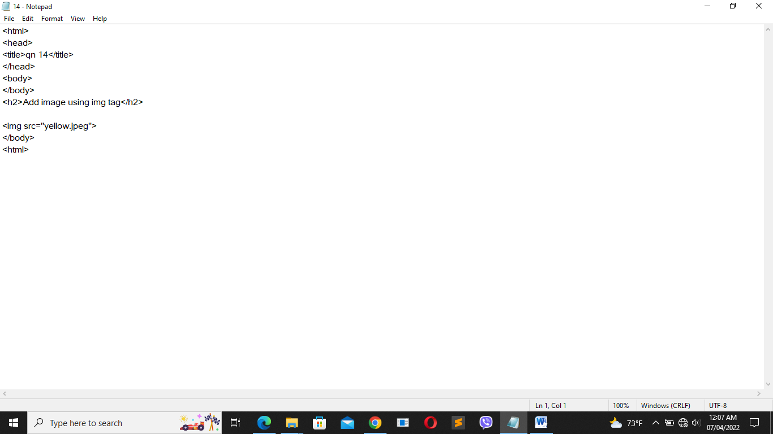

Output:

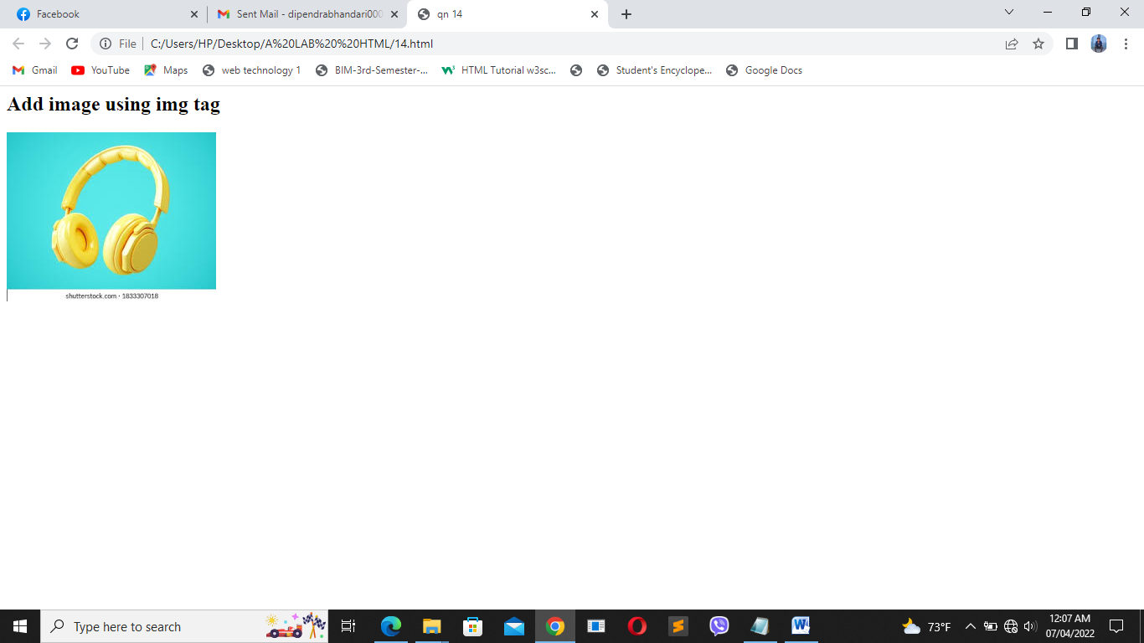

1. Write the HTML code to print the following output:

Code:

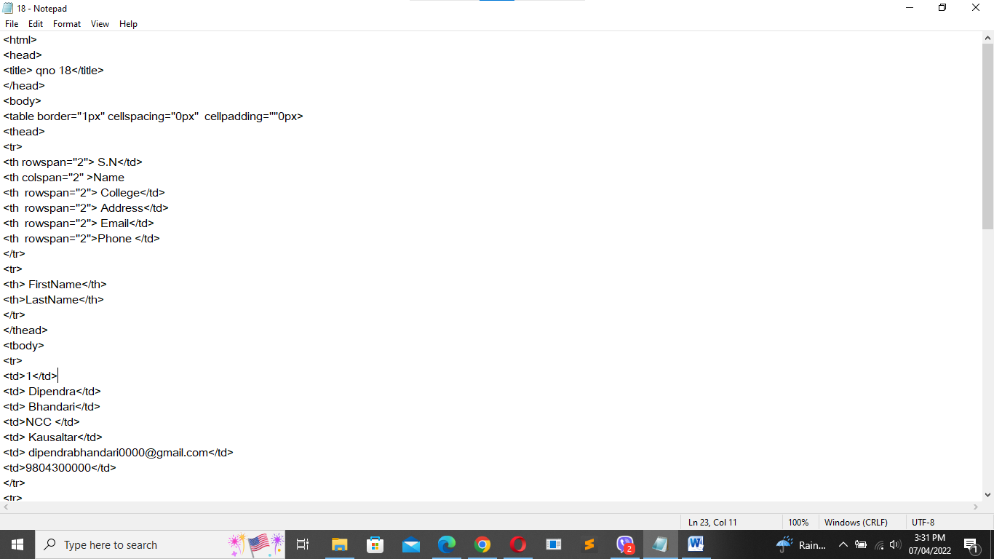

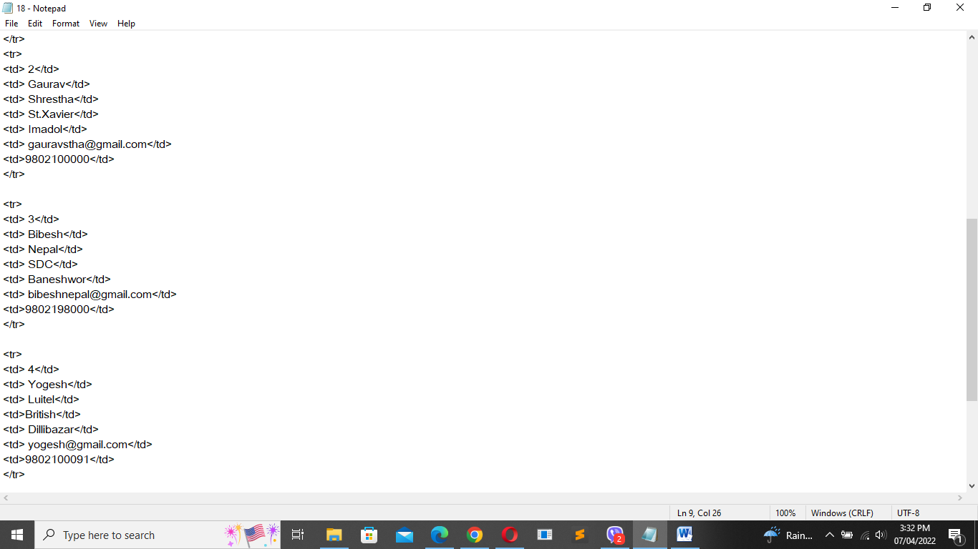

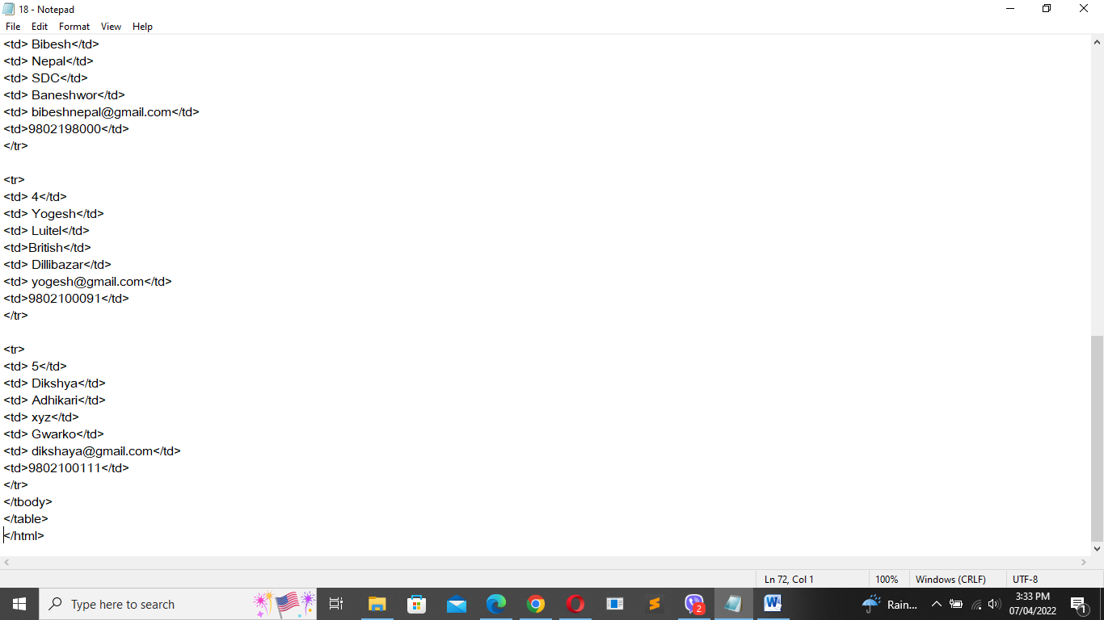

Output:

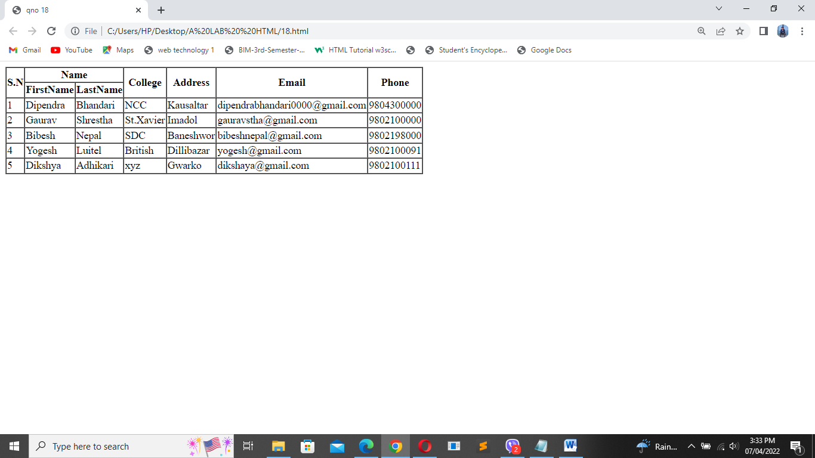

1. Write XHTML code to demonstrate the use of Nested table with rowspan and colspan attribute

Code:

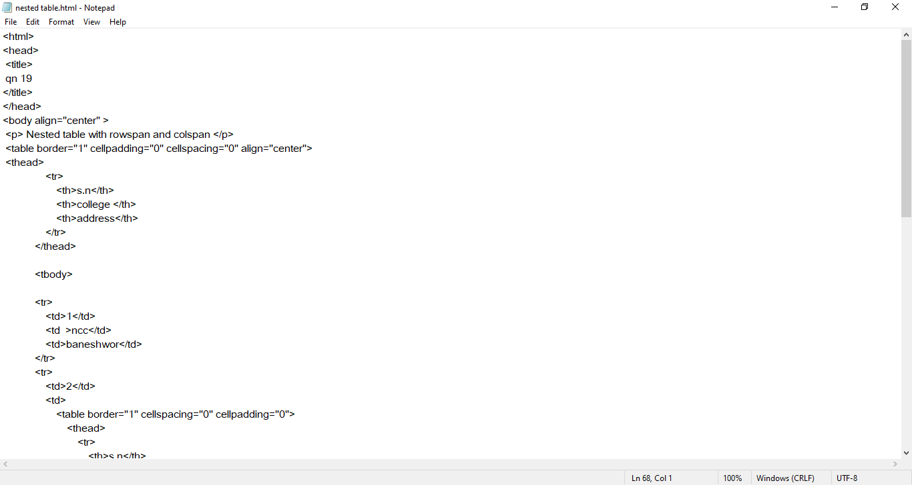

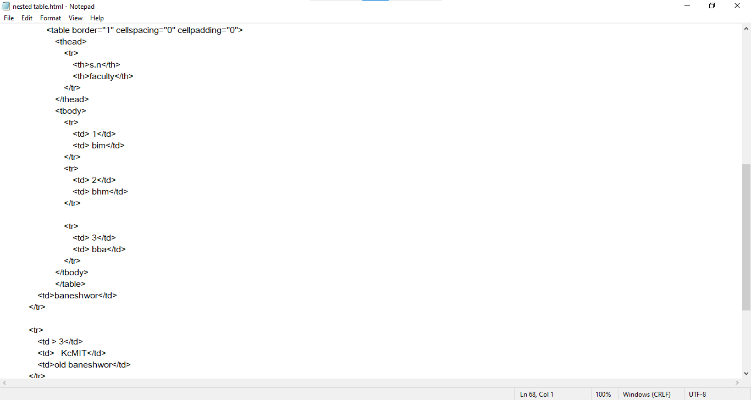

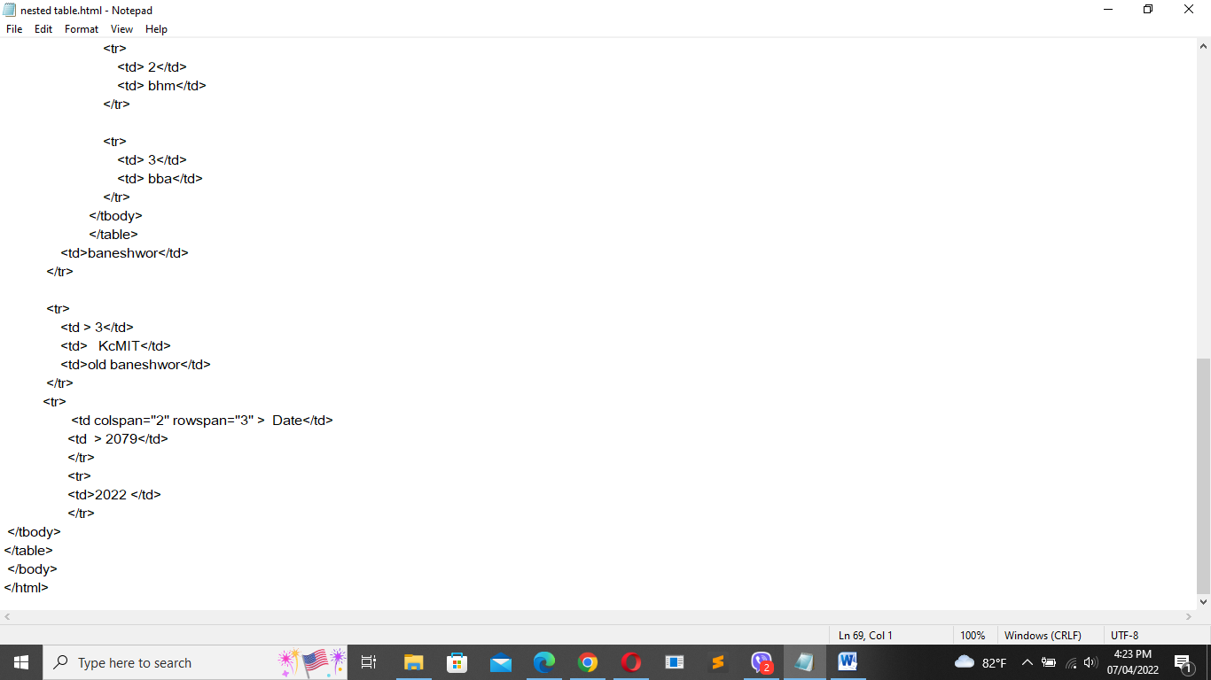

Output:

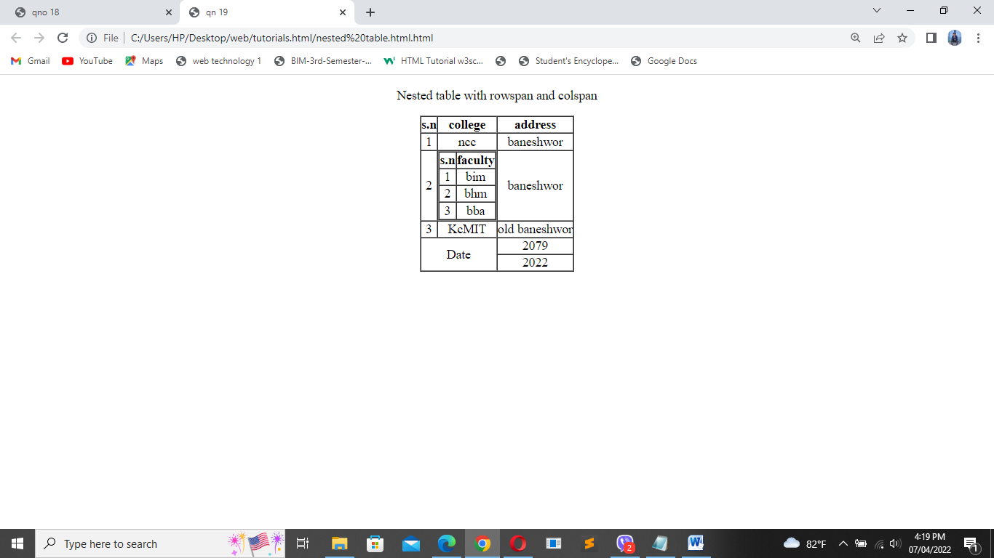

1. Write the code and provide the output of form of previous board questions.